The Senate Finance Committee Proposal Lowers Non-Group Premiums
Jonathan Gruber, MIT
October 12, 2009

The Senate Finance Committee proposal includes health insurance and delivery system reforms, new options, premium assistance, and other proposals to improve quality, affordable health care for all Americans through state-based exchanges. The premiums that individuals will face in these exchanges are, according to the non-partisan Congressional Budget Office, considerably lower than what they would face in the existing non-group insurance market, due to the market reforms put in place by the SFC plan and the market economies of new exchanges. This report, and the attached slides, illustrates this point by relying solely on analysis available from CBO, as well as the details of the premium assistance available through tax credits in the Senate Finance plan. In addition, following the usual assumption in my model I assume that health insurance premiums grow at 6%/year.

The analysis focused on two types of individuals and a family: a 25 year old, a 60 year old, and a family of four where the family head is 45 years old. I examined these family types at four different income levels, where they would be getting four different tax credits for premiums. The impact is for 2016, the first fully-phased in year of the reforms, although income is expressed in $2009 for ease of interpretation. The analysis compares what they would pay if they are current insured in the non-group market versus what they will pay in the exchange.

Under the Senate Finance Committee proposal, the average estimate premium changes would mean:

- Sizeable premium savings for young. An individual aged 25 at $19,000 in income (175% of poverty) would benefit from tax credits and would save, on average, $685. A higher income young person could always buy a “bronze” plan without tax credits for a savings of $230. Moreover, they could qualify for a catastrophic policy – also known as a “young invincible” policy. This policy would cost on average only $1190, saving them $585 at all income levels.

- Even larger premium savings for older individuals. A person age 60 with income at $19,000 (175% of poverty) would save, on average, $7890. A person at age 60 with income at $40,600 (375% of poverty) would continue to benefit from tax credits and would save, on average, $4100. Even at a high enough income level to not benefit from tax credits, older persons purchasing a bronze plan would save about $2800.

- Also large premium savings for a family. A family with income at $38,000 (175% of poverty) would save, on average, $8550. That same family with higher income could buy a “bronze” plan without tax credits at a savings of $2430 over current non-group prices.

Conclusion: The non-partisan analysis based on information from the CBO shows clearly that for those facing purchase in the non-group market, the SFC bill will deliver savings ranging from several hundred dollars for the youngest consumers to over $8500 for families. This is in addition to all the other benefits that this legislation will deliver to those consumers – in particular the guarantee, unavailable in most states, that prices would not be raised or the policy revoked if they became ill.
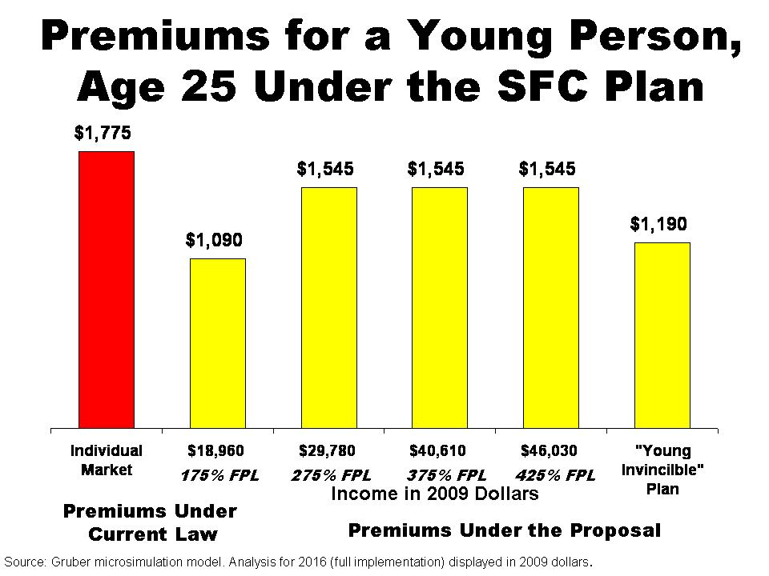
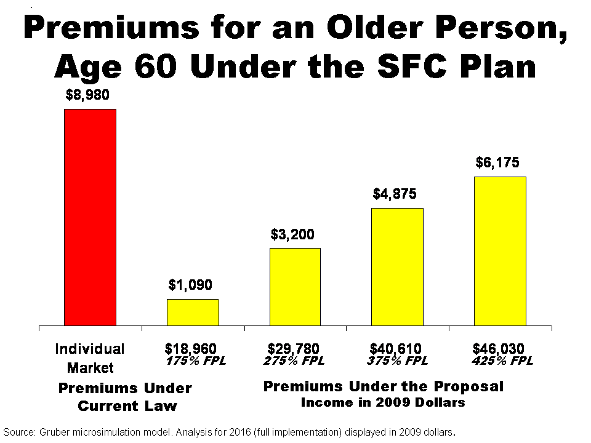
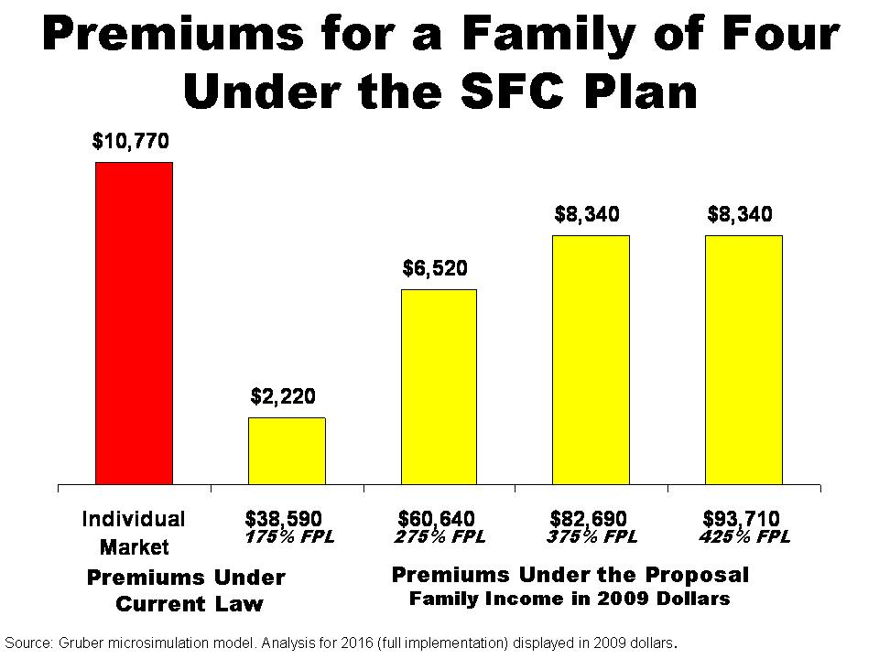

The CBO reports that a typical non-group single plan is projected to cost $6000 in 2016. For the family plan for a family of four, I assume the premium is 2.7 times the single premium, as with group insurance. I assume that there is a 5:1 ratio between premiums for 25 and 60 year olds in the existing non-group market. The CBO also reports that a silver plan (with an actuarial value of 0.70) would cost on average $5000 in 2016. The Bronze plan has an AV of 0.65, so the price is 93% as high. I assume that the premium for a 25 year old is half that amount and for a 60 year old is twice that amount for a total age band of 4:1. For the catastrophic premium, I assume and actuarial value of 0.5. For a family plan, I assume that the premium is 2.7 times the single premium.

