Toplines

Kaiser Family Foundation/MTV
Youth, Voting & the 2000 Election

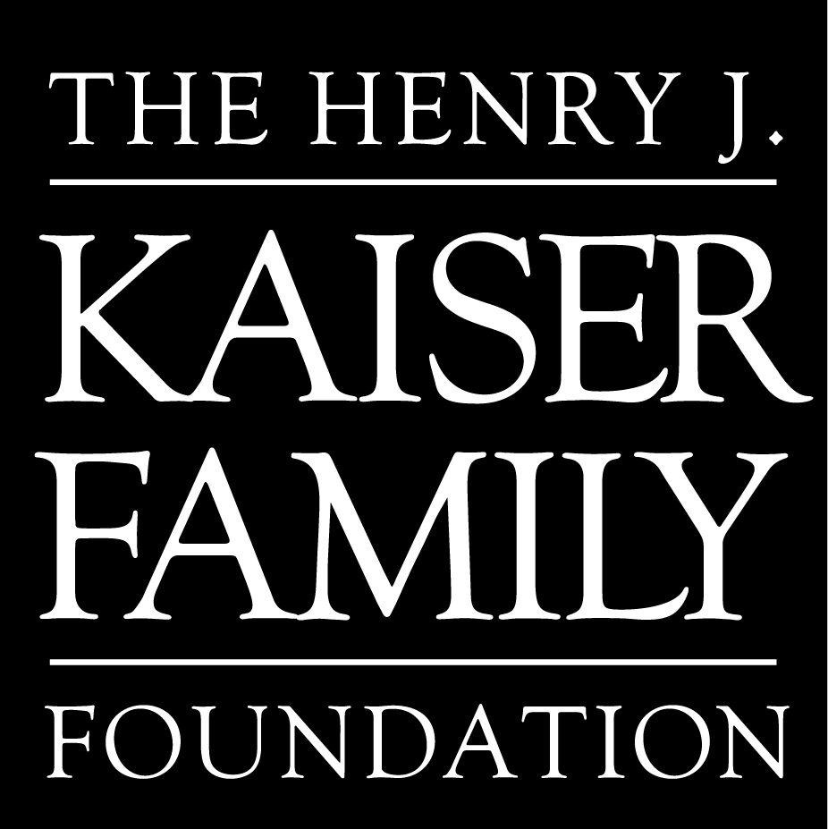

September 2000

Methodology

Youth, Voting & the 2000 Election reports on the results of a national random sample telephone survey of 813 adults ages 18-24. The questionnaire was designed and analyzed by staff at the Henry J. Kaiser Family Foundation, MTV: Music Television and Princeton Survey Research Associates (PSRA), and was conducted by PSRA August 9-27, 2000. The margin of error is plus or minus 4 percent.

Topline Results

N = 813 Adults ages 18 to 24.
Margin of error: plus or minus 4 percent
Square root of design effect: 1.1
Field period: August 9-27, 2000

* Note: Some results may not add to 100% due to rounding.

1. Many people are not registered to vote because they’re too busy or move around too often. Are you NOW registered to vote in your precinct or election district, or haven’t you had a chance to register yet?

Yes, registered | 50
No, not registered | 48
(VOL.) Don’t have to register | *
Don’t know/Refused | 1

2. Do you, yourself plan to vote in the presidential election this November? (IF YES, ASK) How certain are you that you will vote? Are you absolutely certain, fairly certain, or not certain?

Yes, absolutely certain | 46
Yes, fairly certain | 18
Yes, but not certain | 9
No, not planning to vote | 23
Don’t know/Refused | 4

- Suppose the 2000 presidential election were being held TODAY and you had to choose between the Democratic ticket of Al Gore and Joseph Lieberman; the Republican ticket of George W. Bush and Dick Cheney; the Reform Party ticket headed by Pat Buchanan and Ezola Foster; and the Green Party ticket of Ralph Nader and Winona LaDuke. Who would you vote for? As of TODAY, do you LEAN more to Gore and Leiberman, the Democrats; Bush and Cheney, the Republicans; Buchanan and Foster of the Reform Party; or Nader and LaDuke of the Green Party?

Gore/Lieberman | 39
Bush/Cheney | 43
Buchanan/Foster | 2
Nader/LaDuke | 4
Undecided/Other candidate | 12

- Suppose there were only two choices on the ballot and you HAD TO CHOOSE between the Democratic ticket of Al Gore and Joseph Leiberman, and the Republican ticket of George Bush and Dick Cheney. Who would you vote for? As of TODAY, do you LEAN more toward Gore and Lieberman, the Democrats; or Bush and Cheney, the Republicans?

Gore/Lieberman | 44
Bush/Cheney | 47
Undecided/Other candidate | 9

5. Do you think things in this country are generally going in the right direction or are they seriously off on the wrong track?

Right direction | 60
Wrong track | 32
Don’t know/Refused | 9

6. Overall, how much thought have you given to the coming Presidential election this year? Would you say you have given the election a lot of thought, some thought, only a little thought, or hardly any thought at all?

A lot | 20
Some | 37
Only a little | 22
Hardly any (include "none") | 21
Don't know/Refused | *

- Now, I’m going to read you a list of four things that might influence your vote in the presidential election. Please tell me which ONE of them you think will be MOST important when you decide who to vote for. Will it be…(READ AND ROTATE)

The candidates’ stand on issues | 42
The candidates’ character and moral values | 26
The candidates’ leadership abilities | 20
The candidates’ experience | 9
(VOL.) Other/None of these | 2
(VOL.) Not interested in politics/Don’t plan to vote | *
Don’t know/Refused | 2

8. Does George W. Bush's choice of Dick Cheney as his vice presidential running-mate make you MORE likely to support the Republican ticket, LESS likely to support the Republican ticket, or does it not make any difference?

More likely | 10
Less likely | 9
No difference | 77
Don't know/Refused | 3

9. Does Al Gore's choice of Joseph Lieberman as his vice presidential running-mate make you MORE likely to support the Democratic ticket, LESS likely to support the Democratic ticket, or does it not make any difference?

More likely | 17
Less likely | 8
No difference | 72
Don't know/Refused | 3

10. Suppose you needed advice about a personal problem or issue. If you could talk to either Al Gore or George W. Bush, who would you be more comfortable going to for help?

Al Gore | 39
George W. Bush | 39
(VOL.) Either/ Neither | 15
Don't know/Refused | 7

11. How big an impact do you think the outcome of this year's presidential election will have on YOU PERSONALLY? Do you think it will have a big impact, a small impact, or no real impact at all?

Big impact | 26
Small impact | 43
No impact at all | 27
Don't know/Refused | 4

12. I am going to read a short list of phrases that could be used to describe the two main presidential candidates. Regardless of which candidate you support, please tell me whether you think each is a better description of Al Gore or George W. Bush. In your opinion, which candidate…(INSERT. ROTATE.)

 | Gore | Bush | Neither/Both | DK
a. Has stronger leadership qualities | 32 | 53 | 4 | 11
b. Is more honest and ethical | 38 | 39 | 8 | 15
c. Is more intelligent and well informed | 38 | 41 | 7 | 14
d. Cares more about people your age | 46 | 28 | 8 | 18
e. Shares your views on most major political issues | 40 | 43 | 4 | 14

13. For you personally, what is the SINGLE BIGGEST PROBLEM OR CONCERN that you have in your own life today? (OPEN END.)

Jobs/Money/Financial pressure |  |  | 23
Education, total |  |  | 20
Education, general | 12
Education cost | 8
The Economy/Taxes |  |  | 6
Violence/Guns |  |  | 4
Children/Child care |  |  | 4
What to do with life |  |  | 4
Health care |  |  | 3
Foreign policy/Global issues |  |  | *
OTHER |  |  | 19
Nothing/None/No problems really |  |  | 8
Don’t know/Refused |  |  | 14

14. Please tell me how important you think each of the following issues will be in determining your vote for president. (First,) what about...(INSERT. ROTATE.)? Will this issue be very important, somewhat important, not too important, or not at all important in determining your vote?

 | Very  Important | Somewhat Important | Not too Important | Not at all Important | DK
a. National defense and Foreign policy | 39 | 42 | 11 | 7 | 1
b. Crime and violence | 74 | 22 | 3 | 1 | *
c. Taxes | 65 | 27 | 5 | 2 | 1
d. Education | 86 | 12 | * | 1 | *
e. The economy and jobs | 79 | 18 | 2 | 1 | *
f. Gun control | 60 | 24 | 10 | 4 | 1
g. Health care | 68 | 25 | 5 | 2 | *
h. Abortion | 49 | 25 | 11 | 13 | 1
i. The Environment | 62 | 29 | 6 | 2 | *
j. Civil rights | 67 | 25 | 5 | 2 | 1
k. Social Security | 56 | 34 | 6 | 3 | 1
l. The privacy of personal and financial information | 61 | 27 | 8 | 3 | *
m. Campaign finance reform | 14 | 36 | 25 | 22 | 4
n. Poverty | 59 | 32 | 5 | 3 | 1
o. Moral values | 60 | 28 | 7 | 3 | 1

15. As you may know, the federal government now has a budget SURPLUS, meaning it's taking in more money than it spends. In your opinion, which ONE of the following would you most like to see the surplus used for. Would you most like to see the surplus used…(READ. ROTATE ITEMS.)

To provide funds to improve education | 44
To protect programs such as Medicare and Social Security | 13
To increase the number of Americans who have health insurance coverage | 13
For tax cuts | 10
To pay off the national debt more quickly | 10
To increase funding for the fight against HIV and AIDS | 8
Don’t know/Refused | 2

Now I would like to ask you about some specific issues being discussed in this year's presidential election.

16. On the issue of ABORTION. Please tell me which comes closer to your own view, even if neither is exactly right:

a. Government should not interfere with a woman’s right to choose an abortion. | 51
b. Abortion should be PROHIBITED, EXCEPT in cases of rape, incest, or to protect the life of the mother. | 46
(VOL.) Neither/Both | 1
Don’t know/Refused | 2

17. On the issue of AFFIRMATIVE ACTION. Please tell me which comes closer to your own view, even if neither is exactly right:

a. Affirmative action programs are still needed to counteract the effects of discrimination against minorities, as long as there are no rigid quotas. | 50
b. Affirmative action programs have gone too far in favoring minorities, and should be phased out because they unfairly discriminate against non-minority groups. | 44
(VOL.) Neither/Both | 3
Don’t know/Refused | 3

- On the issue of SOCIAL SECURITY. Please tell me which comes closer to your own view, even if neither is exactly right:

a. Individuals should be allowed to take a portion of the money set aside for their Social Security and invest it in the stock market, so they can try to earn additional money for their retirement. | 44
b. Social Security should remain a guaranteed retirement benefit; by putting even a portion of Social Security benefits in the stock market, there is a risk that people will not have the money they’ll need in retirement. | 53
(VOL.) Neither/Both | 2
Don’t know/Refused | 1

19. Which ONE of the following three statements comes closest to your opinion about what the government should do for people who don’t have health insurance? Do you think the government should…(READ. DO NOT ROTATE.)

a. Keep things the way they are now | 10
b. Make a LIMITED effort to provide health insurance for some of the uninsured, which would not require a tax increase | 51
c. Make a MAJOR effort to provide health insurance for nearly all Americans, which would require a tax increase | 37
Don’t know/Refused | 2

20. Now I’m going to read you a short list of health care issues and concerns facing this country today. As I read each one, please tell me how important you think it is. (First,/How about)…(READ. ROTATE.) Do you think this issue is very important, somewhat important, not too important, or not at all important?

 | Very Important |  | Somewhat Important | Not too Important | Not at all Important | DK
a. Increasing the number of Americans who have health insurance coverage | 59 |  | 33 | 5 | 2 | 1
b. Protecting patients' rights in HMO’s and managed care plans | 59 | 34 |  | 5 | 2 | 1
c. Making the Medicare program financially sound | 58 | 34 |  | 6 | 2 | 1
d. Reducing the cost of health care | 66 | 29 |  | 3 | 1 | 1
e. Providing prescription drug coverage for older Americans | 64 |  | 31 | 3 | 2 | *
f. Providing long-term care, such as nursing homes for older Americans | 56 | 37 |  | 4 | 2 | *

21. Now I am going to read you a list of eight health problems FACING YOUNG PEOPLE in this country today. After I read the entire list, please tell me which ONE you feel is the MOST IMPORTANT health problem for young people today. Here's the list. (READ. ROTATE.)

HIV and AIDS | 16
Illegal drug use | 16
Violence | 14
Teen pregnancy | 14
Sexually Transmitted Diseases other than HIV | 10
Alcohol abuse | 10
Youth smoking | 10
Depression | 9
Other (SPECIFY) | 1
Don't know/Refused | 1

22. Now I am going to read two statements about sex education in schools today. Please tell me which comes closer to your view, even if neither is exactly right.

a. Federal funding should be made available to sex education classes that teach ONLY abstinence as a way to prevent unwanted pregnancies and the spread of sexually transmitted diseases. | 17
b. Federal funding should be made available to sex education classes that teach students a variety of ways to prevent pregnancy and the spread of STD's, such as abstinence, and the use of condoms and other forms of birth control. | 80
(VOL.) Neither/Both | 1
Don't know/Refused | 1

23. As you may know, there is a federal law that mandates increased penalties for people who commit crimes against blacks and other minorities out of prejudice against them. Would you favor or oppose a similar federal law that would mandate increased penalties for people who commit hate crimes out of prejudice toward gays and lesbians?

Favor | 77
Oppose | 19
Don’t know/Refused | 4

24. Do you think there should or should NOT be laws that provide gay and lesbian couples who form civil unions the same legal rights as married couples when it comes to things like inheritance, employer provided health insurance and hospital visits?

Should be | 61
Should not be | 34
Don’t know/Refused | 5

25. Now, I’m going to read you a list of proposals some candidates have made. For each one, please tell me whether you favor or oppose each proposal…(INSERT. ROTATE.) Do you favor or oppose this proposal?

 | Favor | Oppose | DK
a. The government should offer parents “vouchers” to send their children to the school of their choice, including private or religious schools | 73 | 25 | 3
b. The government should impose tougher gun laws, such as a mandatory waiting period, and criminal background checks for those who want to buy guns | 84 | 16 | 1
- The government should ban any new offshore oil drilling | 36 | 52 | 12
d. The government should protect the rights of health care patients by allowing people to sue their health plans for malpractice | 76 | 21 | 3
e. The government should legalize the personal use of marijuana | 42 | 54 | 3

26. There are lots of reasons why people don't always vote. As far as reasons why YOU PERSONALLY may not vote in this year's election, please tell me whether you completely agree, mostly agree, mostly DISAGREE, or completely DISAGREE with the following? (First/Next)…(INSERT. ROTATE.)

Based on those who are not absolutely certain they will vote (n=436).

 | Completely Agree | Mostly  Agree | Mostly  Disagree | Completely  Disagree | DK
a. I don’t know enough about the candidates to vote | 24 | 36 | 20 | 17 | 3
b. It’s complicated to register to vote where I live | 3 | 9 | 29 | 53 | 6
c. It’s difficult for me to get out to the polls to vote | 14 | 17 | 23 | 44 | 2
d. I don’t like any of the candidates | 10 | 20 | 30 | 35 | 5
e. Politics is just about money and lying, and I don’t want to involve myself in it | 13 | 26 | 29 | 28 | 3
f. I can make more of a difference by getting involved in my community than by voting in elections | 24 | 34 | 27 | 13 | 2
g. All candidates are basically the same, so it doesn’t make much difference to me who gets elected | 8 | 20 | 31 | 40 | 2
h. My vote doesn't matter | 10 | 15 | 27 | 46 | 2

27. Here are some statements people have made about politics in general. Please tell me whether you completely agree, mostly agree, mostly DISAGREE, or completely DISAGREE? (First/Next)…(READ. ROTATE.)

 | Completely Agree | Mostly  Agree | Mostly  Disagree | Completely  Disagree | DK
a. Politicians in Washington are out of touch with the concerns of people my age | 25 | 45 | 20 | 7 | 3
b. Voting gives people like me some say about how the government runs things | 30 | 45 | 15 | 9 | 1

- Thinking about the presidential election overall, in your opinion what is the most important issue NOT BEING DISCUSSED by the candidates? (OPEN END.)

Education/Increased funding for education | 7
Crime/Violence/Guns | 5
Foreign policy/Military | 4
Alcohol/Drugs | 4
Health care | 3
Issues concerning young adults | 3
The Economy/Jobs | 3
Abortion | 3
Welfare/Poverty | 2
Family issues/Children’s issues | 2
OTHER | 16
Nothing/Don’t know | 51

DEMOGRAPHICS

D1. What is your age? (RECORD ACTUAL AGE)

Age 18-20 | 45
Age 21-24 | 55

D2. In general, would you describe your political views as…(READ. DO NOT ROTATE.)

Total Conservative |  | 32
Very conservative | 3
Conservative | 29
Moderate |  | 34
Total Liberal |  | 29
Liberal | 20
Very liberal | 9
(VOL.) Don’t know/Refused |  | 5

D3. In politics TODAY, do you consider yourself a Republican, Democrat, or Independent? As of TODAY do you LEAN more toward the Republican Party or the Democratic Party?

Republican | 25
Democrat | 28
Independent | 41
(VOL.) No preference/Not interested in politics | 2
(VOL.) Other party | *
Don’t know/Refused | 3
Republican/Lean Republican | 41
Democrat/Lean Democrat | 45

D4. How important would you say religion is in your own life…(READ.)

Very important | 50
Somewhat important | 30
Not too important | 11
Not at all important | 9
Don’t know/Refused | *

D5. Are you now married, LIVING AS married, divorced, separated or have you never been married?

Married | 14
Living as married | 4
Divorced | 1
Separated | 2
Never been married/Single | 79
Refused | *

D6. Are you now employed full-time, part-time, or are you not employed for pay?

Employed full-time | 52
Employed part-time | 26
Not employed | 21
(VOL.) Disabled | *
(VOL.) Student | 1
(VOL.) Other | *
Don’t know/Refused | *

D7. Are you also a full- or part-time student?

Total Students | 55
Yes, full-time | 40
Yes, part-time | 15
No | 46

D8. What is the LAST grade or class that you COMPLETED in school? (READ ONLY IF NECESSARY.)

None, or grade 1-8 | 1
High school incomplete (grades 9-11) | 10
High school graduate (grade 12 or GED certificate) | 37
Business, technical, or vocational school AFTER high school | 2
Some college, no 4-year degree | 36
College graduate (B.S., B.A., or other 4-year degree) | 12
Post-graduate training or professional schooling after college (e.g., toward a master's degree or Ph.D.; law or medical school) | 2
Don't know/Refused | *

D9. Are you, yourself, of Hispanic or Latino background, such as Mexican, Puerto Rican, Cuban, or some other Latin American background?

Yes | 14
No | 86
Don't know/Refused | *

D10. What is your race? Are you white, black, Asian, or some other race? IF RESPONDENT SAYS "HISPANIC" OR "LATINO" ASK: Do you consider yourself a WHITE Hispanic/Latino or a BLACK Hispanic/Latino? THEN CODE AS WHITE (1) OR BLACK (2). IF RESPONDENT REFUSES TO CHOOSE BETWEEN WHITE OR BLACK HISPANIC, CODE AS OTHER (4).

White | 75
Black/African-American | 16
Asian | 3
Other or mixed race (SPECIFY) | 5
Don't know/Refused | 2

D11. Respondent’s Sex:

Male | 49
Female | 51

The Henry J. Kaiser Family Foundation

The Kaiser Family Foundation, based in Menlo Park, California, is an independent national health care philanthropy and is not associated with Kaiser Permanente or Kaiser Industries. This survey was conducted as part of the Foundation’s Program on the Entertainment Media & Public Health, which was established to examine the impact of entertainment media on society, and to work with the entertainment industry to help convey important health messages to the public.

The Henry J. Kaiser Family Foundation
2400 Sand Hill Road
Menlo Park, CA 94025
650-854-9400
Facsimile: 650-854-4800

Washington Office:
1450 G Street N.W., Suite 250
Washington, DC 20005
202-347-5270
Facsimile: 202-347-5274
www.kff.org

Additional free copies of this publication (#3058)
are available on the Foundation’s website at www.kff.org
or by calling the Kaiser Family Foundation’s
Publication Requestion Line at 1-800-656-4533.
00-1567D-01

